• Assignment No. 2: Jenkins CI/CD Deployment on AWS EC2

- Console Output

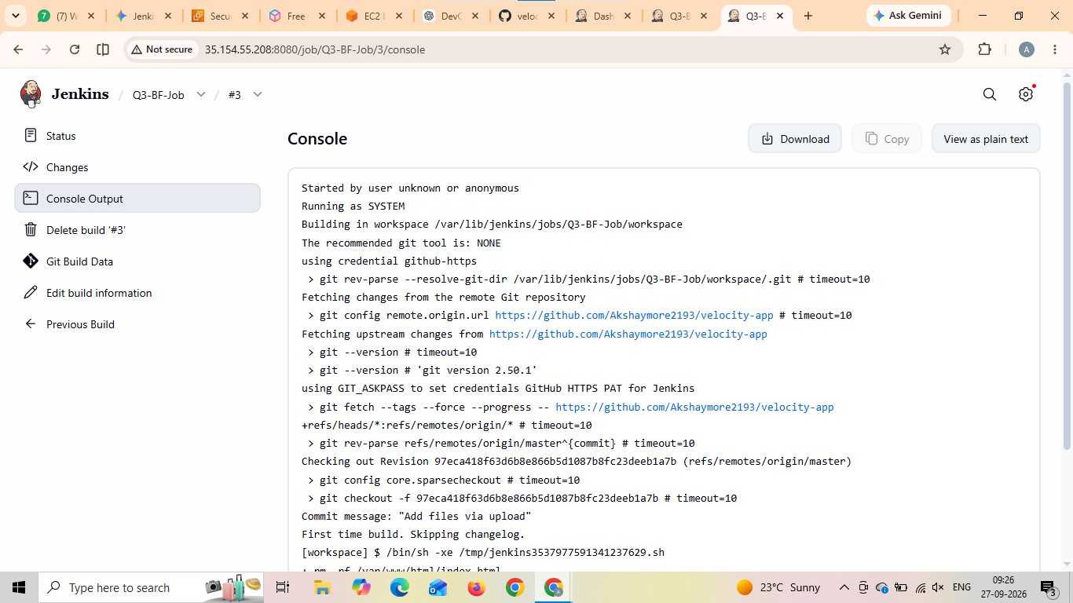

- Job Configuration

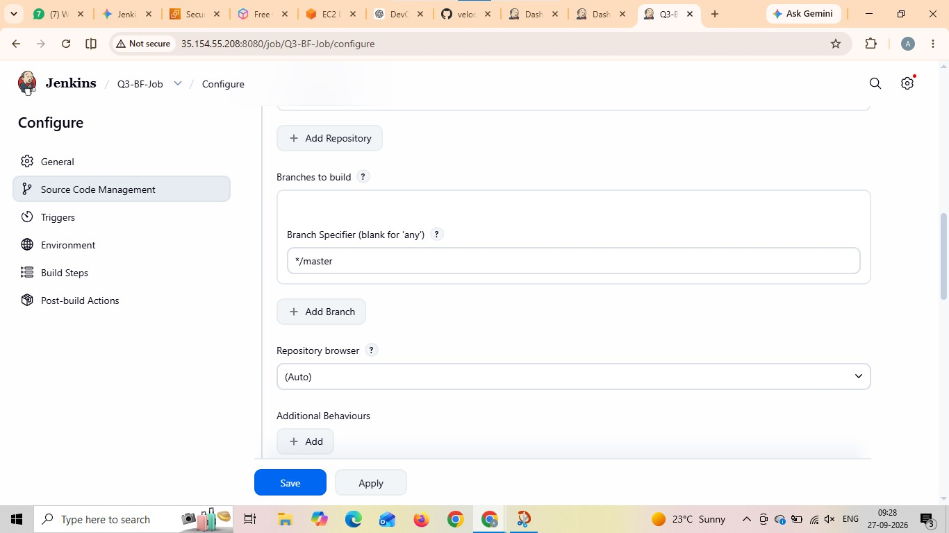

- Application Page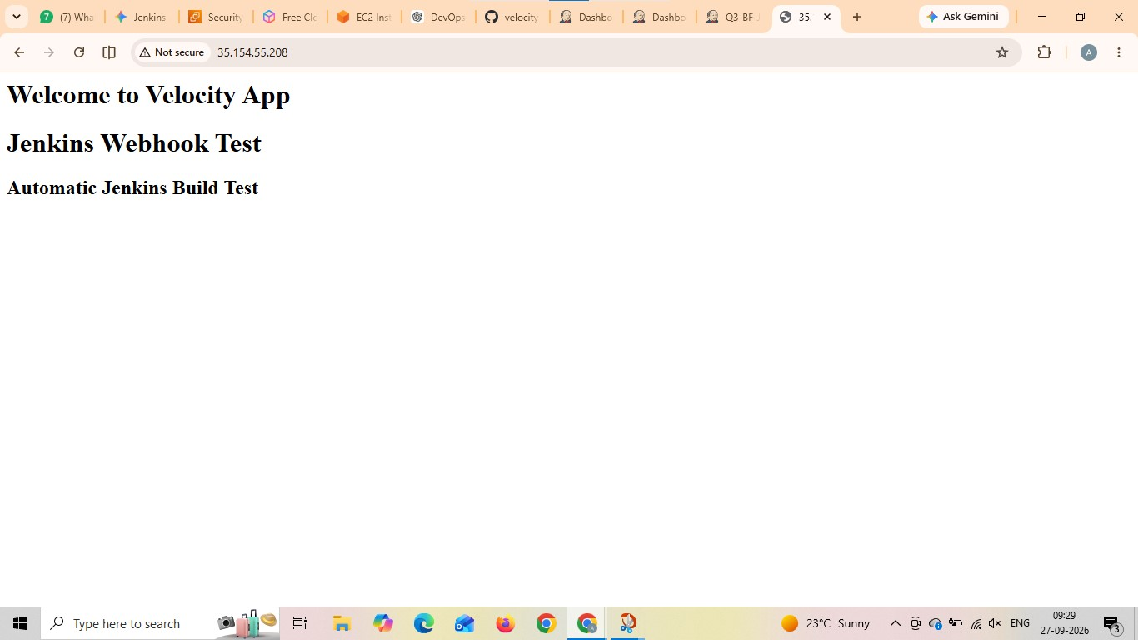

- GitHub Repository Page

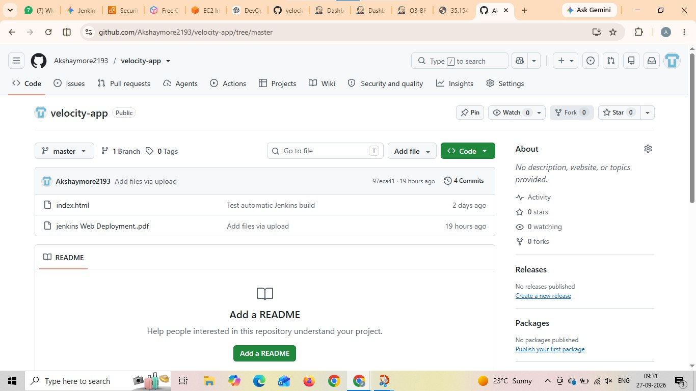

- Jenkins Dashboard Status

